

COVID TRACKER

 Design Document

By Aruna Dahal

**Table of Content**

1.Introduction…………………………………………………………………………………...2

2. Application Objectives…………………………………………………………….………....2

3.Key Components……………………………………………………………………..……….2

4. Architecture of the Application…………………………………………………………........3

5.Fig4.1 The Overall Design of the App………………………………………………………..3

6. Signup & Login Page………………………………………………………………………...4

7.Fig5.1 Layout Diagram for Login & Signup …………………………………………….......4

8. State Tracking Details………………………………………………………………………..4

9. Fig6.1 Covid data Diagram…………………………………………………………………..5

10. Quick Survey Page……………………………………………………………………….....5

11.UserInterface Diagram for Quick Survey………………………………………….…..........5

12.Mild Symptom……………………………………………………………………………....6

13. Diagram for diagnosis of Mild symptom…………………………………………..……….6

14.No symptoms…………………………………………………………………………….......6

15. Fig Diagram that displays detail of no symptoms…………………………………………..7

16. Notification……………………………………………………………………………….....7

17.Fig8 Diagram that displays notification feature…………………………………………......7

18. Covid data Tracker………………………………………………………………………….8

19. Logout page…………………………………………………………………………………8

20. Data Storage………………………………………………………………………………...8

21. Source code of critical part……………………………………………………………….....9

22. Future prospect of the app…………………………………………………………………10

23. Conclusion……………………………………………………………………………........10

1. **INTRODUCTION**

This is an android application which is completely based on the digital contact tracing and alert notifier concept using GPS locater through which we can get alert notification of cases nearby and diagnose whether the user is suffering from covid wi-19 with the help of quick survey by fetching the symptoms. The major features of the app includes:

* Tracking positive cases across various states of United States.
* Analyzing covid symptoms
* Alert notification

1. **APPLICATION OBJECTIVE**

This application mainly focuses on alerting the people about the emerging COVID cases across them and updating them regarding the active and inactive cases across United States. It alerts the user with mild symptom to perform COVID test to reduce the risk of infection and user with no symptom as safe through quick survey.

1. **KEY COMPONENTS**

The key components of the application consist of its front-end and back-end design part and those are:

* FRONT-END DESIGN:

The front-end of the app is designed using XML and KOTLIN. The login page, survey page and many more are designed using KOTLIN.

* BACK-END:

The backend of the app is designed in the firebase console which is a Backend-as-a-Service (BaaS)and built in Google’s infrastructure. It stores the data in JSON-like documents and helps to develop quality apps and grow their user base.

* Services :

API is used for GPS tracking to detect the active cases across various states.

1. **ARCHITECTURE OF THE APPLICATION**

This overall architecture of the app talks about how the user interacts with this application. In this system, the user needs to login to the application and enter their email address and password. If the user is a new to the app, then he/she might need to sign up and it will require them to enter some of their personal information such as their first and last name, phone number, age, email and create a password as desired. Once the user login to the app, they can see three features which are State-wise Tracking, Quick Survey and About the app. As the user clicks the state-wise tracking option, the user needs to type a name of the state in the search bar and it will give them information about the covid cases about that state along with a graph. The second option is Quick Survey. The Quick Survey page consists of a series of questions that helps the user to identify their risk level for covid-19 according to the answers they gave for those questions. The last option is the about page, which basically gives information about the app, that can help user know about the application and what it does.

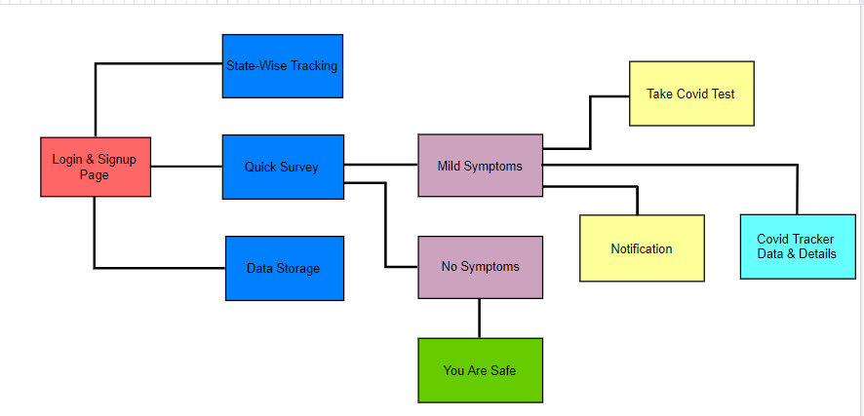

Fig 4.1 The overall Design of the app.

**5. SIGN UP AND LOGIN PAGE**

The first step of the application is logging in or signing up. Whenever the user opens the app, first the login and signup page appears. In case the user is new to the app, they are supposed to sign up and are asked to fill out a blank form with their personal about them which includes age, Name, email, Phone number etc. After the user enters all that information in application, it will let them access it. All those details or information entered by the user are stored in the database console of the app. If the user has already registered to this app, they can just enter their credentials and login to the app.

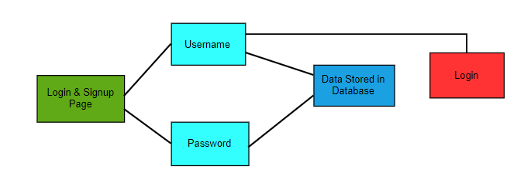

Fig 5.1Layout diagram for Login & Signup.

1. **STATE TRACKING DETAILS**

The data regarding every state in United States are extracted through the Center Of Disease Control (CDC) website. The link to the website is

([https://covid.cdc.gov/covid-data-tracker/#datatracker-home](https://covid.cdc.gov/covid-data-tracker/)). shows all the active, confirmed, recovered and death cases in different states within United States.

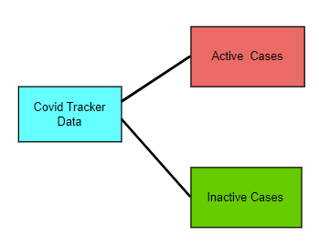

Fig 6.1 Covid Data diagram.

**7. QUICK SURVEY PAGE**

After the user login to the app with the help of their credentials, they will be given with three option. Quick survey option will be one of the options. After the user click the quick survey option, they will have to answer couple of questions in that survey. After they are done answering the survey question, the app will display result of the survey which shows if someone has mild symptom or no symptom. In case of mild symptom, more survey questions will be asked and after that the user will receive a pop-up notification telling them about their risk of infection and in case if the user is identified to be at risk, the app will suggest him/her to take the covid test.

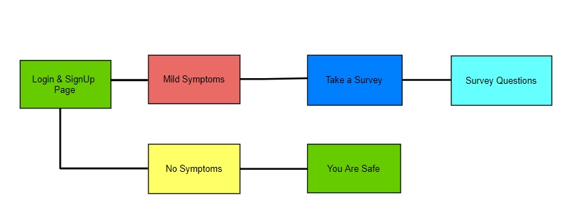

Fig 7 User Interface diagram for Quick Survey.

* 1. **MILD SYMPTOM**

In case if the user is identified to have a mild symptom, the user will be asked more survey questions. After they are done with the survey questions then there will be a pop-up notification displayed on their screen which will notify user about, he/she being at risk of infection and needs it will even suggest to have COVID test in case of high risk of infection.

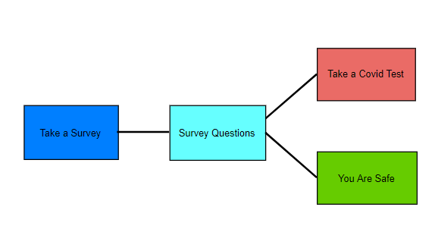

Fig 7.1 Diagram for Diagnoses of Mild symptom.

**7.2 NO SYMPTOM**

In case of no symptom, there will be a pop-up notification display for the user which will notify them that they have no risk of getting infected and the user is safe from COVID infection. And those users are counted among those who have no COVID symptoms.

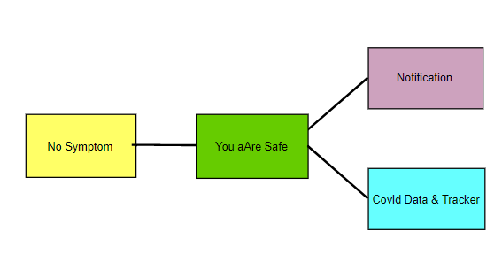

Fig 7.2 Diagram that displays detail of No symptom.

The detail description regarding the notification and covid app data are done below.

**8. NOTIFICATIONS**

As the user login to the app, the details stored in firebase cloud are fetched to get the notifications from nearby location. The notifications in the phone status bar gives alert message regarding the active COVID cases near to the user. The area is calculated within certain radius through the GPS locator. The app also sends notification for the app update.

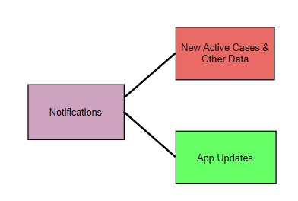

Fig 8 Diagram that describes Notification feature.

1. **COVID DATA TRACKER**

The data showed in the app regarding the covid cases of different states within Unites States are collected from CDC website ([https://covid.cdc.gov/covid-data-tracker/#datatracker-home](https://covid.cdc.gov/covid-data-tracker/)). It shows all the active, confirmed, recovered and death cases in different states across the world. It also displays the cases updated within 24hours.

**10. LOGOUT PAGE**

The final part of this app is the log out page where the user just needs to click on the three-dot menu option at the top right. After clicking on that option, you will see a pop-up message which shows two choice yes or no. If the user wants to logout, they can simply click yes logout out of the app.

**11. DATA STORAGE**

The data entered by the user is stored in cloud storage and firebase is used as a cloud storage here. While logging in to the app, the details stored in firebase cloud are fetched to get the notifications from nearby location. The data can be easily extracted by the backend interface for analysis of the data.

1. **SOURCE CODE OF THE CRITICAL PART**

I found this as the most critical part of the design of the application as the configuration of the application is done here and I faced a lot of problems while fixing this piece of code. I had to refer to various online websites to learn where the error lies and after quite a time of understanding and analyzing i was finally able to fix this configuration code.

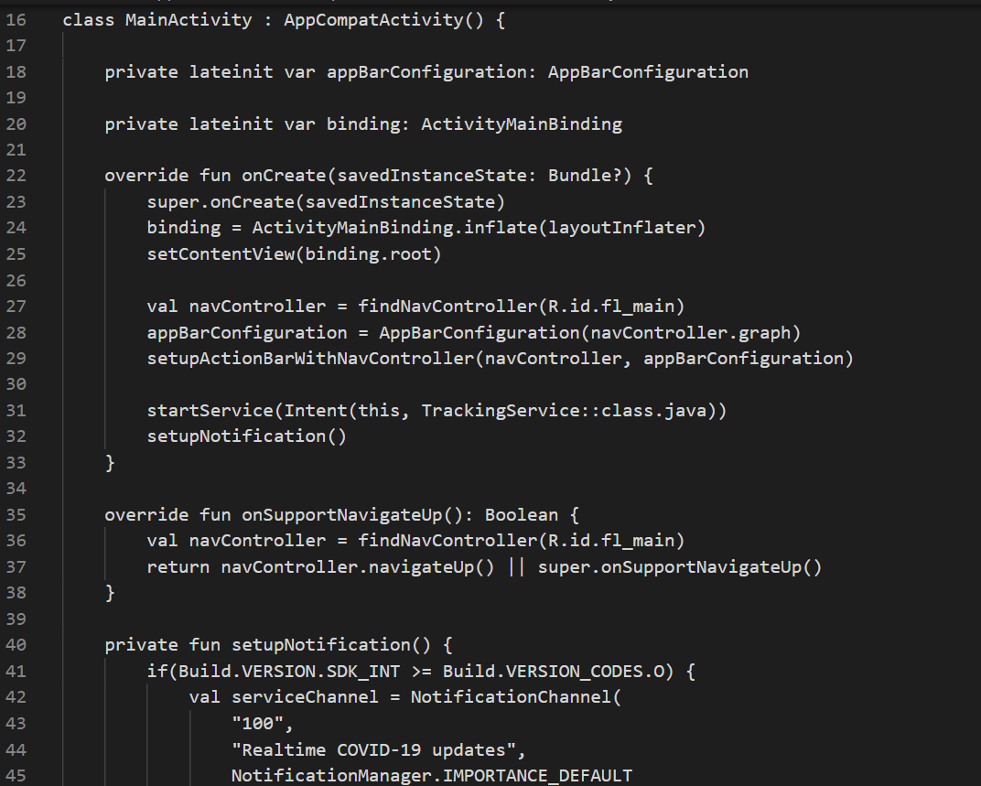

Fig12.1 Diagram showing the critical source code from project.

**FUTURE PROSPECTS OF THE APPLICATION**

The potential of digital contact tracing to slow the spread of a virus has been quietly explored for over a decade before the COVID-19 outbreak. But it can actually be effective in the hard-to-model complexity of real-world social networks. In the future this app should be able to support multiple platforms such as iOS, Linux and android and provide covid information for all the countries rather than just United States.

**CONCLUSION**

The analysis and design of the covid tracker app is shown in this document. This app has the potential for digital contact tracing by tracing the active cases near the user’s locality and checking the COVID status across various states in United States.